Automatic Assessment and Error Identification of Student Answers Consisting of Venn and Euler Diagrams

Abstract—Venn and Euler diagrams are well-defined mathematical diagram types, which are the major representation methods of Set Theory. Venn and Euler Diagrams exist in various media types such as printed format in books, raster images and vector images in electronic media. Also Venn & Euler diagrams are part of major mathematics examinations in secondary education such as London Ordinary Level and SAT. Although computer representation of different diagram types such as Entity-Relationhip diagrams, and automatic assessment of student answers containing these diagram types addressed, no such research has been done for Venn and Euler diagrams. In this research, we present a system capable of automatically assessing student answers consisting of Venn and Euler diagrams. The student answer is compared against a model answer, and marks are allocated according to a marking rubric.

Index Terms— Diagram Assessment, Venn Diagram, Euler Diagram, Set Theory, Diagram interpretation
- Introduction
Venn & Euler diagrams are a significant part of mathematics, especially in exams of secondary education, such as London Ordinary Level and SAT Mathematics. With the increasing interest in automated assessment of student answers for various subjects including Mathematics, there is a need for an automated system to assess answers containing these types of diagrams. Significant research has been done to understand mathematical diagrams in few domains such as coordinate graphs [2] as well as charts [5] (bar charts, pie charts). However, there is no research done to interpret Venn and Euler diagrams.
Venn diagrams can be described as diagrams that represent pictorial relations among sets. Venn diagrams are a specialized instance of a more general notation for representing relationships among a set of classes of concepts referred to as Euler diagrams [20]. Definition of Venn and Euler diagrams varies throughout the literature [9]. Generally, Venn and Euler diagrams can be defined as a finite set of labelled, closed curves. The closed curves in the diagram partition the plane into minimal regions, where each minimal region is a connected component of the plane inside a set of curves [20]. While a Venn diagram contains all the minimal regions, Euler diagrams omit the empty minimal regions. Normally two and three sets of Venn and Euler diagrams are being used in most of the educational contexts such as mathematics and science. Representation up to 6 sets is less complex in the graphical representation.

Figure 1. Example of a Venn and an Euler Diagram
This paper presents a system capable of automatically assessing a student answer containing a Venn or Euler diagram. It is also capable of identifying the errors (if any) in the student answers, and generating feedback. The system accepts diagrams represented in the scalable vector graphic (SVG) format. Then abstract set information is extracted from these SVG images. Set information extracted from a student answer is compared against the same extracted from a teacher-provided model answer. Marks are allocated to the student answer using a marking rubric, which should also be provided by the teacher. Marking rubric may contain alternative marking methods for a same question/ sub-question. Maximum collective mark is extracted as the final mark for a student answer. Also errors are associated with the diagram are identified and feedback is given.

For the evaluation, we have collected answers from a secondary school examination in Sri Lanka that had Venn and Euler diagram questions Also we gave a Venn and Euler diagram question paper with four questions to university undergraduate and postgraduate students and collected answers in handwritten format. These questions were extracted from the GCE O/L exam held in Sri Lanka. This exam is very much similar to the Landon ordinary level exam. We manually graded those answer sheets according to the marking rubric. Collected answer sheets were converted to SVG and graded using the system. Marking results produced from the system were validated against the manual marking, which showed an accuracy of 100%.
This paper is arranged into following sections: Section II describes the related work. Details of the implemented system are included in Section III. Section IV provides an evaluation of the system. Finally, Section V concludes the paper with possible future extensions.
- Related Work

Mathematical diagram recognition, understanding and evaluation is a relatively new research field, and we are not aware of any related research that dealt with Venn and Euler diagrams. However, there exists research on understanding x-y graphs and gene diagrams [2], a nd charts (both 2D and 3D) [4]
As for diagram assessment, Tsintsifas et al [8] developed a framework called DATsys that can be used to understand and evaluate diagrams in formative assessments. They were able to develop the diagram input system that can handle various diagram types. Thomas et al [9, 10, and 12] developed a computer aided assessment system that can handle graph-based diagrams such as Entity-Relationship (E-R) diagrams and flow charts, where information can be represented as data nodes and relations. They also introduced a marking criteria based on “Minimal Meaningful Units” that can be applied to diagrams that are represented using nodes and their relationships. Brett et al [15] developed a feedback system that can work with graph-based diagrams by following the work of Tsintsifas et al [8]. They also discussed a simple evaluation method and developed a grammar for E-R diagrams. Batmaz et al [18] developed a diagram drawing tool that can be used for semi-automated database diagram assessment. Tselonis et al [6] discussed a marking method based on marking matrices for graph-based diagrams. However, these marking techniques cannot be directly adopted to Venn and Euler diagram marking due to the structure differences that exist between Venn/ Euler diagrams and graph equivalent diagrams.

Mathematical representation method are exists to represent a set theory but not for a Venn or Euler diagram. Burton et al [28] developed an abstract syntax to represent an Euler diagram. Modified version of abstract syntax is developed to capture all the information of both Venn and Euler diagrams.

As for machine representation of marking rubrics, Richard [26] presented a way of representing a rubric document in a machine understandable format using XML. Li [27] developed a language for mathematical problem representation called Mathematics Assessment Markup Language (MAML), using XML, MathML and SVG. Researchers claim that they can represent any mathematical problem using MAML mark-up language.
- Methodology
In this section we describe the implementation details of the Venn and Euler diagram parser, marking rubric model and the diagram assessment module.
- High-Level Architecture
Fig. 2 shows the high-level architecture of the implemented system. The teacher has to provide a marking rubric and a model diagram to the system for assessment. System extracts and stores the abstract set nformation from this diagram. Student diagram is processed similarly. In the assessment module, these two abstract representations are compared and the student answer is graded according to the marking rubric.
Input diagram is given in the SVG format. It contains geometric details of SVG primitive objects such as circles, ellipses and rectangles, as well as other details such as presentation details. Since it contains presentation and SVG specific data, SVG image has to be parsed and primitive shape details should be extracted to create the abstract set representation. These details are needed to build Venn and Euler data information.
From the parsed SVG, sets are identified by finding the Jordan curves. After finding the sets, relevant set labels are identified using a heuristic algorithm After identifying the sets, text labels are associated with the correct minimal regions or zones (set of minimal regions) based on the Venn diagram domain knowledge. Several heuristic algorithms are used to deal with human errors. Heuristic parameter tuning depends on the source of the Venn and Euler diagrams such as distance closeness parameters depends on the font sizes based on the SVG drawing tool. After associating the text labels, Venn diagram is built using the extracted knowledge and output is created as structured XML, which contains only the Venn and Euler details without the initial image presentation details such as orientations, and set curve shapes.
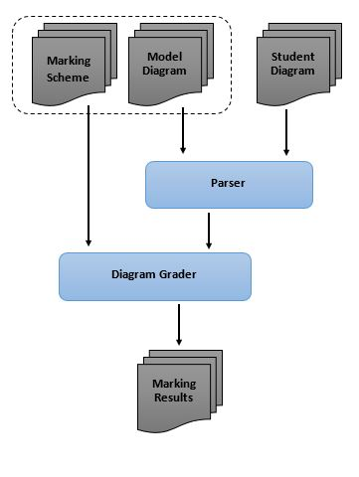
Figure 2. The High-Level Architecture of the system
In the Grader, student diagram is validated for structure similarity such as the number-of-sets. If the structures of two diagrams are matched, assessment is continued. Initially, the set labels in the model diagram and the student diagram are matched using a sentence similarity matching algorithm. After set matching is completed, the diagram is graded according to the marking rubric, which is provided by a teacher.

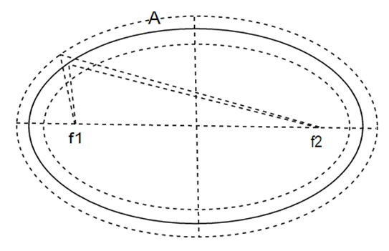
Figure 5. Boundary condition check for an ellipse.

Figure 6. Pseudo code of the text association mapping
Calculate the centroid and the area of all minimal regions
Create pool of text labels except set labels
For (pool of text labels)
If (is text label on a border of a set)
Text association with corresponding minimal
region
Else
Text association with relevant zone
Normalization

- Venn Data Structure
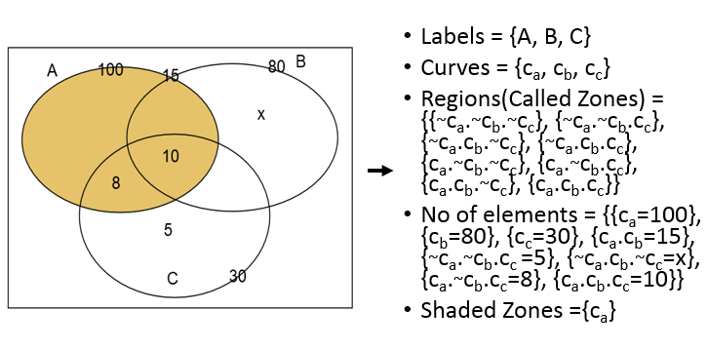
Figure 7. Venn/ Euler abstract syntax
Figure 7 shows the abstact sysntax developed for the Venn and Euler data output by extending the abstract syntax introduced by Burton et al [28]. We modified the zone notation and added extra detail segment “No of elements” to handle all the information given in a diagram. In the abstract syntax, there are five top-level tags; (1) Label: Set Labels: labels of the sets, (2) Curves: Related curve drawn to represent a set, (3) Regions: Represented all the zones and minimal regions, (4) No of elements: Elements in the sets, zones or minimal regions, (5) Shaded Zones: zones or regions that are shaded.
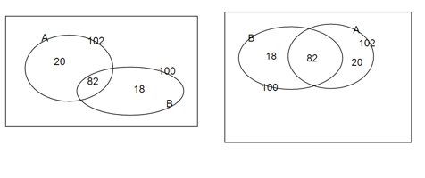
Figure 8. Two Venn diagram answers providing same information
Set order is ignored in the Venn information XML structure. Depending on the set order, different Venn or Euler diagrams may produce equivalent solutions. When reading the output XML ignoring the order of sets, it will produce the same Venn or Euler data.
For a given set, output XML can have a limited number (n!) of equivalent formats depending on the arrangement of sets. Figure 8 shows the two Venn diagrams representing the same set information. Variation of Venn or Euler diagram for 2 sets produces 2 equivalent XML formats. Figure 9 shows the equivalent formats for above Venn diagrams.
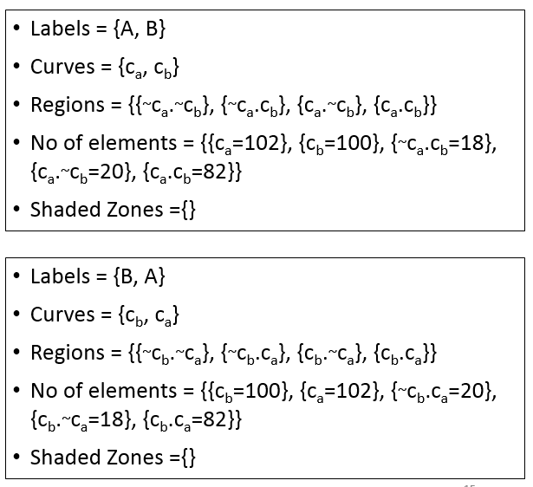
- Marking Rubric
Figure 9. Equivalent representations using the syntax for Venn diagram answers provided in Fig. 8
Figure 10 shows the marking rubric structure for Venn and Euler diagrams. Since the marking rubric for the same diagram type can change with the time, the tag has a version attribute that is intended for future changes. Each rubric contains type and question tag. Type tag specifies the diagram category such as “Venn Diagram” and “Euler Diagram”. Question tag contains all the specific marking details. Question tag has “id” (specify the relevant question) and “totalMarks” attributes. Each part of the question is described under “sub_question” tag since the question can have any number of sub-parts with dedicated marking-rules. Each sub_question can have multiple “mark_set” tags, each specifying one possible solution. Each mark set includes three major tags; (1) “mandatory”: specifying the pre-requirements in order for the given solution to be true, (2) data: condition for the evaluation, (3) feedback: suggested feedback by the teacher. Mark set has “method” attribute specifying the way to give marks such as “all of the conditions have to be true”, “at least 3 conditions have to be true” and “any condition has to be true”. “data” part contains the diagram quries that has to be checked given in Figure 11. It can check sets, zones, labels and colors regardless of the drawing orientation.

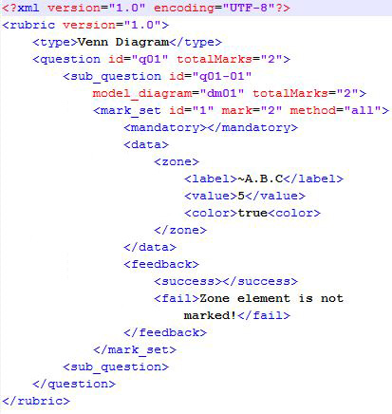

Figure 10. Example marking rubric for a question
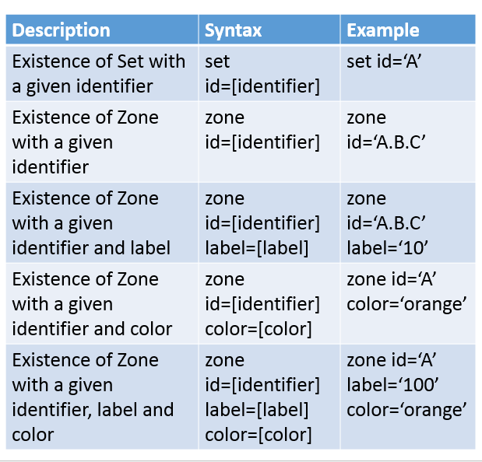
Figure 11. Rubric diagram queries for the assessment
- Text Label Matching
Labels in the diagrams are written in the Sinhala language (the official language in Sri Lanka) and it can be a single word or a short phrase. Figure 12 shows the pseudo code of the label validation module. First, it checks if the labels in the student’s answer directly match with one of the labels found in the model answer labels. If it matches, the system evaluates student label as correct. If not, using the question and the labels provided in the model, this module forms a word joint vector (Bag of Words).
T= tuning parameter
labelValidation (question, studentLabel, modelLabel,
T)
jointVector[] = createBagOfWords (question,
studentLabel, modelLabel)
similarityMetrix[][]=createSimilarityM (jointVector[],
studentLabel, modelLabel)
sim_{max} =getMaxCosineSim (similarityMetrix)
editDistance=levenshteinEditDist (studentLabel,
modelLabel)
maxEditDistance=maxLevenshteinDist (studentLabel,
modelLabel)

if(minEditDistance=<maxEditDistance*sim_{max}*T)
validatedSuccessfully
else
validationFailed
Then Similarity matrix is formed using model answer labels and the student answer labels. Next, the system calculates cosine similarity between pairs of column vectors in the matrix. Finally, it selects the maximum similarity value and the relevant model answer and it calculates the Levenshtein (edit) distance (LD-min). Then it calculates the maximum edit distance (LD-max) between the selected label and the label in the student’s answer. Finally, it checks whether minimum edit distance is less than or equal to the maximum edit distance between student unit and the selected unit multiplied by a tolerance value (T_{val}). Using the training data collection, the tolerance value is tuned to be 0.51.
Figure 12. Pseudo code of the label validation module.
- Assessment Module
In the assessment, the diagram is initially checked for mandatory requirements such as the number of sets. If the number of sets matches, similar sets are identified by matching the set names. If a diagram has N sets, at least N-1 set names have to be matched correctly for the assessment.
After matching relevant sets, according to the marking rubric, for each sub-question, all mark-sets are evaluated until at least one mark set gains maximum marks allocated for that sub-question. Then the mark set with maximum marks for that sub-question is collected as final marks for that sub-question.
Similarly, each sub-question in the marking rubric is graded and total mark is calculated from collective marks for sub-questions.
- Error identification and feedback generation
In the error identification process major 13 types of errors are identified. These errors are identified by analysis students answer scrips given to Venn/Euler diagram questions, consulting with domain experts such as educational advisers and school teachers. Also the feedback is optimized to give enough details about the error made by a student. Table I shows the identified major 13 errors.

TABLE I. Venn/Euler Diagram Errors

Error | Feedback
Unidentified Diagram/ No Sets Presented | No Sets Available in the diagram, Make sure to draw sets with Ellipse, Circles or Rectangles
Missing Set Labels | All the sets are not properly labelled
No of sets drawn are different | No of sets are not matching with given model answer, you need to draw diagram with <no of sets> sets
Minimum region is not exist | Minimum region is not exists for <region identifier>
Zone is not exist | Zone is not exists for <region identifier>
Minimal region is not colored | Minimal Region <region identifier> is not colored.
Zone is not colored | Zone <region identifier> is not colored.
Incorrect Minimal Region values | <region identifier> Minimal Region value is not correct. It should be <expected value> instead for <value given>
Incorrect Zone values | <region identifier> Zone value is not correct. It should be <expected value> instead for <value given>
Minimal region value is not presented | <region identifier> Minimal Region value is not present. It should be marked as <expected value>
Zone value is not presented | <region identifier> Zone value is not present. It should be marked as <expected value>
Minimal Region contains multiple elements | Extra elements presented in the Minimal Region <region identifier>. Required element is <{expected element}>
Zone contains multiple elements | Extra elements presented in the Zone <region identifier>. Required element is <{expected element}>

- Implementation and Analysis
- Implementation

Figure 13. Model answer for a question

Figure 14. Student answer for a question
Figure 13 shows a model answer for a Venn diagram question that has 3 sets presenting sport details of a class of students (Even though research validated using the Sinhala Language, have use an example in English so that wider audience can understand). A student answer is given in Figure 14, which represents the same set details. Set orientation is different in two diagrams, as well as label positions. Set labels have differences and have spelling mistakes (the third set is labelled as “Caram” instead of “Carom”). In the set label matching phase, these sets are matched. {“Badminton”, “Play Batminton”}, {“Cricket”, “Play Cricket”} and {“Carom”, “Play Caram”} is identified as matching pairs. Then the student diagram is marked according to the marking rubric by comparing the data tuples in the parsed XML and the results will be presented. Since in the set theory set order details are not significant, by omitting the sets order in the XML Venn data, the equivalency of two diagrams can be measured.

- Analysis
Assessment module was tuned using the Venn diagrams gathered from university undergraduates, which are drawn directly using an SVG editor. For the evaluation, we collected hand-written answer scripts, which collectively contained 3 Venn and 4 Euler diagrams from university undergraduates and grade 10 school students. In total, we had 85 Venn & Euler diagrams. Those diagrams were hand-drawn. Therefore they were converted to Vector format using an SVG editor before given to the system. The model answer for each question was drawn similar to the marking scheme and the marking rubric was generated according to the marking scheme provided originally in the exams. Grader successfully graded all of those diagrams, having a collective accuracy of 100%.
TABLE I I. EVALUATION RESULTS

Diagram No. | Diagram Type | Total Diagrams | Correctly Marked against manual assessment | Accuracy
1 | Venn | 7 | 7 | 100%
2 | Euler | 10 | 10 | 100%
3 | Euler | 8 | 8 | 100%
4 | Venn | 8 | 8 | 100%
5 | Venn | 19 | 19 | 100%
6 | Venn | 33 | 33 | 100%

Diagram 5 and 6 contain 2 sets and remaining diagrams contains 3 sets. Diagram 5 and 6 collected from school student answer scripts and remaining from university undergraduates.
- Conclusions

In this research, we have successfully established the required methods to interpret Venn or Euler diagrams represented in SVG vector format, introduced a generic format to represent a Venn or Euler diagram, and introduced a marking rubric modeling method and an assessment method for Venn & Euler diagrams. We believe that the solution we have introduced will help to develop educational learning systems and system that require Venn and Euler diagram similarity measurements.
The grader is optimized for the Diagrams given in O/L exams in the Sri Lanka. Assessment module can be extended for other languages and different exams.
This method can be easily extended into other vector formats of images since conversion methods of pixel images format into vector format are already developed.
Acknowledgment
Provided upon paper acceptance.
References
- R. P. Futrelle, I. Kakadiaris, J. Alexander, C. M. Carriero, N. Nikolakis, and J. M. Futrelle, “Understanding diagrams in technical documents,” in IEEE Computer, 1992, Vol. 25(7), pp. 75-78.
- R. P. Futrelle and N. Nikolakis, “Efficient analysis of complex diagrams using constraint-based parsing. In Document Analysis and Recognition,” in Proceedings of the Third International Conference on IEEE, 1995, Vol. 2, pp. 782-790.
- R. Futrelle, “Ambiguity in visual language theory and its role in diagram parsing”, in Proceedings 1999 IEEE Symposium on Visual Languages, 1999.
- W. Huang, C. Tan, and W. K. Leow, (2005, August). “Associating text and graphics for scientific chart understanding. In Document Analysis and Recognition,” in Proceedings of the Eighth International Conference on IEEE, 2005, pp. 580-584.
- W. Huang, C. Tan, “A System for Understanding Imaged Infographics and Its Applications,” in Proceedings of the 2007 ACM symposium on Document engineering - DocEng '07, 2007.
- C.Tselonis, J. Sargeant, and M. M. Wood, "Diagram matching for human-computer collaborative assessment," Proceedings of the 9th CAA Conference, 2005.
- R. F. Gunstone and R. T. White, (1986). “Assessing understanding by means of Venn diagrams,” Science Education, Vol 70(2), pp. 151-158, 1986.
- A. Tsintsifas, "A framework for the computer based assessment of diagram based coursework," in Computer Science and Information Technology, 2002.
- N. Smith, P. Thomas, and K. Waugh, "Interpreting imprecise diagrams," Diagrammatic Representation and Inference. Springer Berlin Heidelberg, 2004. 239-241.
- P.Thomas, K. Waugh, and N. Smith, "Experiments in the automatic marking of ER-diagrams," ACM SIGCSE Bulletin, Vol 37(3), pp. 158-162, 2005.
- P. Thomas, K. Waugh, and N. Smith, "Generalised diagramming tools with automatic marking," Innovation in Teaching and Learning in Information and Computer Sciences Vol 10(1), pp. 22-34, 2011.
- P. Thomas, K. Waugh, and N. Smith, "Using patterns in the automatic marking of ER-diagrams," ACM SIGCSE Bulletin. Vol. 38(3), 2006.
- J. Ambikesh and M. Shepperd, "The problem of labels in E-assessment of diagrams," Journal on Educational Resources in Computing (JERIC), Vol 8(4), pp. 12, 2009.
- K. Waugh, P. Thomas, and N. Smith, "Toward the automated assessment of entity-relationship diagrams," 2004.
- B. Bligh and C. A. Higgins, "Formative computer based assessment in diagram based domains." ACM SIGCSE Bulletin, Vol 38(3), pp. 98-102, 2006
- M. Anderson and R. McCartney, "Diagram processing: Computing with diagrams," Artificial Intelligence, Vol 145(1), pp. 181-226, 2003.
- E. Foxley, C. Higgins, T. Hegazy, P. Symeonidis, and A. Tsintsifas. "The coursemaster cba system: Improvements over ceilidh," 2001.
- F. Batmaz and C. J. Hinde, "A diagram drawing tool for semi–automatic assessment of conceptual database diagrams," 2006.
- G. Hoggarth and M. Lockyer, "An automated student diagram assessment system," ACM SIGCSE Bulletin, Vol. 30(3), pp. 122-124, 1998.
- P. A. Rodgers, “A survey of Euler diagrams,” Journal of Visual Languages & Computing, vol 25(3), pp.134-155, 2014.
- (2014) The Vector graphics [Online]. Available: https://en.wikipedia.org/wiki/Vector_graphics
- W. H. Gomaa and A. A. Fahmy, “Short Answer Grading Using String Similarity And Corpus-Based Similarity,” on International Journal of Advanced Computer Science and Applications (IJACSA), 2012, vol 3(11), pp. 122-124.
- M. Mohler, “Text-to-text Semantic Similarity for Automatic Short Answer Grading,” Department of Computer Science, University of North Texas, 2009.
- M. Mohler, “Learning to Grade Short Answer Questions using Semantic Similarity Measures and Dependency Graph Alignments,” Department of Computer Science, University of North Texas, 2011
- Y. Li, D. McLean, Z. A. Bandar, J. D. O'shea and K. Crockett, "Sentence similarity based on semantic nets and corpus statistics," on IEEE transactions on knowledge and data engineering, 2006, vol 18(8), pp1138-1150.
- R. F. Boehme, P. G. Fairweather, U. Farooq, D. Lam and K. Singley, "Method, apparatus and computer program code for automation of assessment using rubrics," U.S. Patent Application No. 10/722,926, 2008
- G. Li, W. Su, Y. Zhao, and L. Li, "Design and implementation of MAML," in Proceedings of ATCM, 2006.
- J. Burton, G. Stapleton, J. Howse, and P. Chapman, “Visualizing Concepts with Euler Diagrams,” in Proceedings of International Conference on Theory and Application of Diagrams, 2014

